Chapter 10, Problem 67.

Find the Thevenin and Norton equivalent circuits at terminals a-b of the circuit in Fig. 10.110.

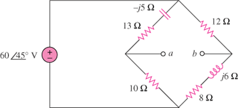

Figure 10.110
For Prob. 10.67.

